# Exercise: CSS & Typography

Problems for exercises and homework for the ["HTML and CSS" course @ SoftUni](https://softuni.bg/courses/html-and-css). Submit your solutions in the SoftUni Judge system at <https://judge.softuni.org/Contests/3332/CSS-Typography>.

## Restaurant Menu

Create a web page like the following:

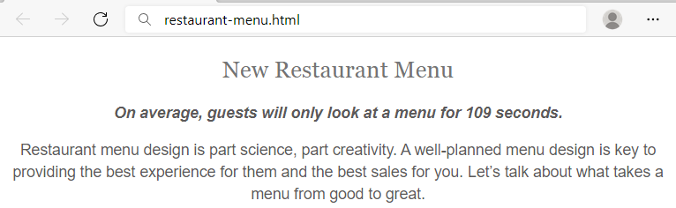

### Constraints

HTML with <body> that contains: <article>, <h1>, <span> and <p>.

CSS:

* <body>:
  + Align the **text** to the **center**
* <h1>:
  + Fonts: **Sentinel** **A**, **Sentinel** **B**, **Georgia**, **Times** **New** **Roman**, **Times**
  + Generic Font: **serif**
  + Font weight **400**
  + Height of the line: **1.15**
  + Text color: #**747474**
  + All characters to be **UPPERCASE**
* <span>:
  + Fonts: **Graphik** **Semibold** **Web**, **Open** **Sans**, **Helvetica** **Neue**, **Helvetica**, **Arial**
  + Generic Font: **sans-serif**
  + Font style: **oblique**
  + Font weight: **600**
  + Font size: **16px**
  + Height of the line: **1.46**
  + Text color: **#5c5a5a**
* <p>:
  + Fonts: **Graphik** **Regular** **Web**, **Helvetica** **Neue**, **Helvetica**, **Arial**
  + Generic Font: **sans-serif**
  + Font weight **400**
  + Font size: **16px**
  + Height of the line: **1.46**
  + Text color: **#5c5a5a**

## Style Lists

Create a web page like the following:

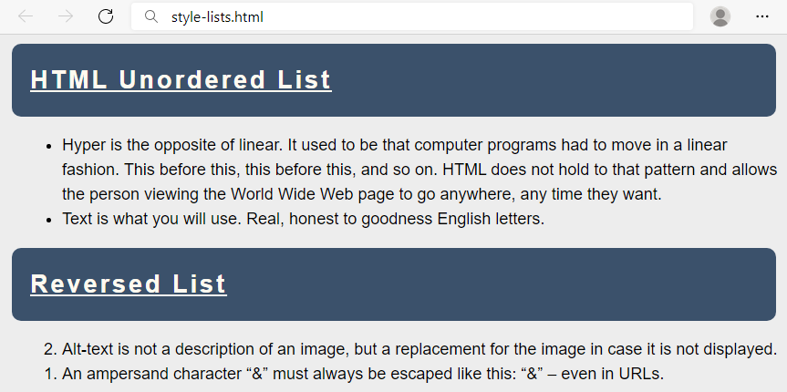

### Constraints

You will be given a skeleton with **filled** **HTML** and an **empty** **CSS** file. Write the missing **CSS** following the guidelines in the task.

* <body>:
  + Font: **Helvetica**
  + Generic Font: **sans-serif**
  + Height of the line: **1.5**
  + Font size: **18px**
  + Background color: **#EDEDED**
* <h2>:
  + Decorate the text with underline
  + Paddings: **20px**
  + **Top** & **bottom** margin **10px**
  + **Left** & **right** margin **5px**
  + Space between letters: **3px**
  + Background color: **#3B516B**
  + Radius of the border: **10px**
  + Text color: **floralwhite**
* <li>:
  + Left margin: **20px**

## Styling Tables

Create a web page like the following:

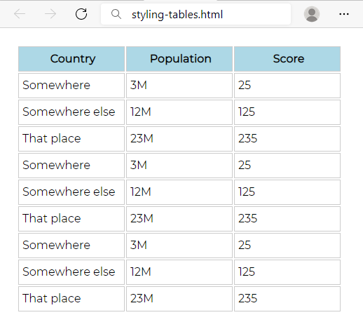

### Constraints

You will be given a skeleton with **filled** **HTML** and an **empty** **CSS** file. Write the missing **CSS** following the guidelines in the task.

* <body>:
  + Font: **Montserrat**
* Use CSS import: @import 'https://fonts.googleapis.com/css?family=Montserrat';
  + Generic Font: **sans-serif**
  + Paddings: **16px**
* <th>:
  + Background color: lightblue
* <th> and <td>:
  + Width: **144px**
  + Height: **32px**
  + Solid border with size 1px and color #ccc
  + Left padding: **5px**

## Buttons CSS

Create a web page like the following:

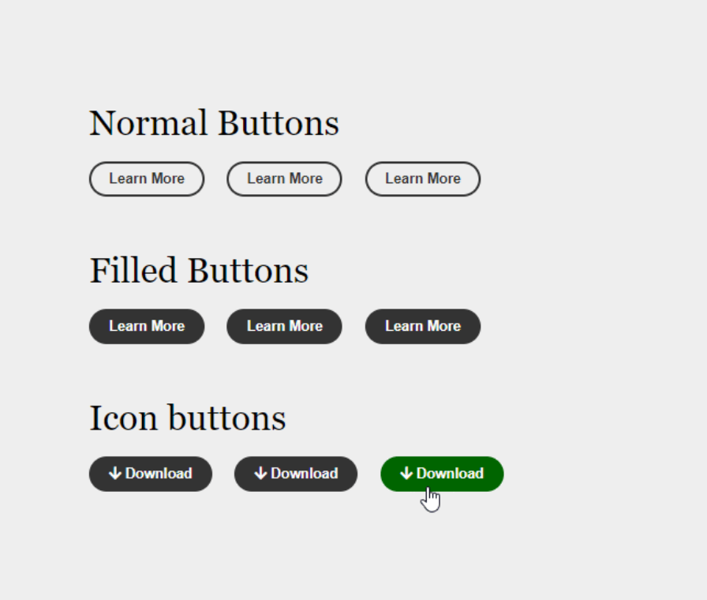

### Constraints

* Create an **"**index.html**"** file with title - **"**Buttons CSS**"**
* Use h2 tag for headings
* Create 9 buttons on 3 rows with class button
  + For the first button in each row use a tag
  + For the next two buttons in the row use button tags
  + The buttons in the second and the third row should have class - fill
  + Every last button in the row should have class - hover
* You must use the following three colors:
  + green(rgb(0, 102, 0))
  + white(rgb(251, 251, 251))
  + gray(rgb(51, 51, 51))
* Use **FontAwesome** for this task. Import it in your CSS, with the **@import** rule.

### Hints

* Change the **cursor** property to [pointer](https://www.w3schools.com/cssref/pr_class_cursor.asp)
* Change the **outline** property to [none](https://www.w3schools.com/Css/css_outline.asp)

## Fonts Speciment – Great Vibes + Raleway

Create a web page like the following:

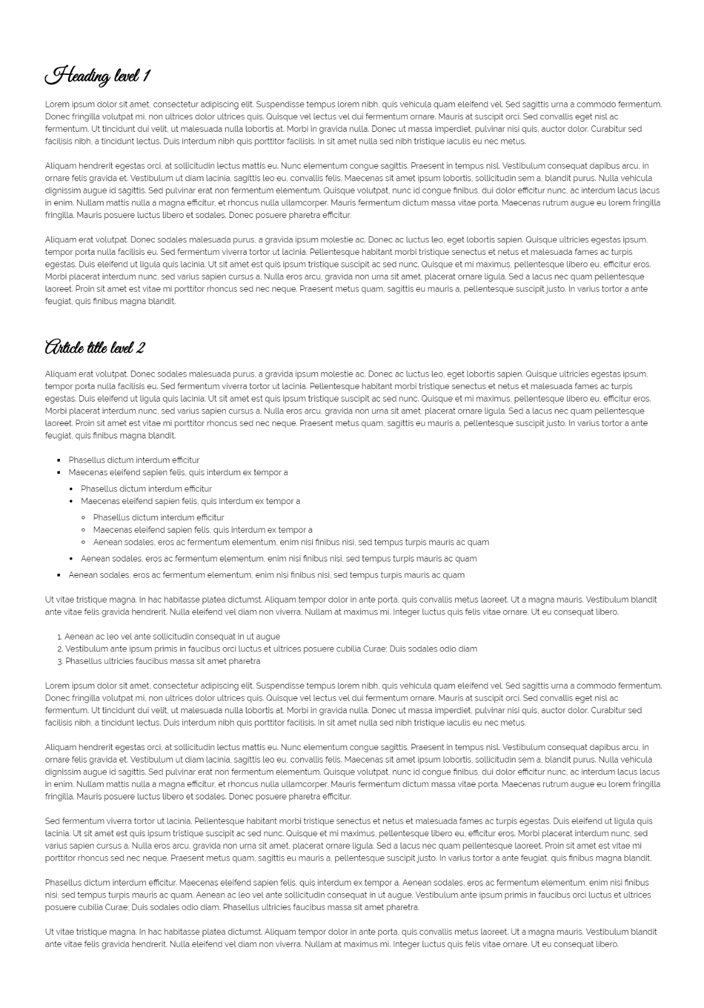

### Constraints

* Create an index.html file with "**Fonts Speciment Great Vibes + Raleway**" title
* Use Raleway, sans-serif font-family for the document
  + Make the font-size 16px
  + Change the line-height to 1.5
* Use Great Vibes, cursive font-family for the headings
  + Change the line-height to 1.2
  + Change the font weight to **bold**

## Contrasting Colors

Create a web page like the following:

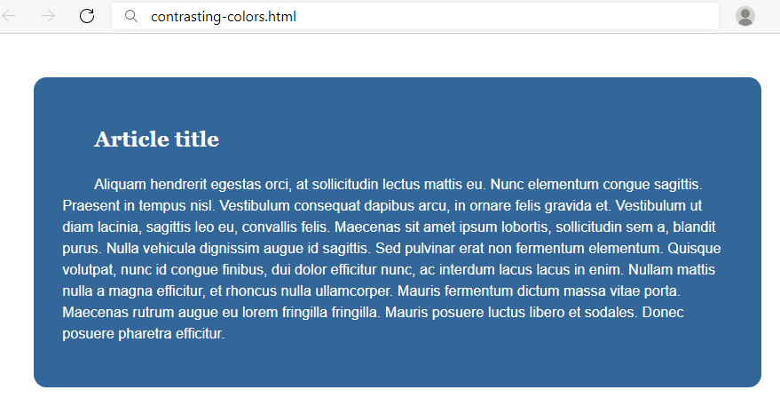

### Constraints

You will be given a skeleton with **filled** **HTML** and an **empty** **CSS** file. Write the missing **CSS** following the guidelines in the task.

* <body>:
  + Font: **Helvetica**
  + Generic Font: **sans-serif**
  + Height of the line: **1.5**
  + Font size: **18px**
  + Background color: **white**
* <article>:
  + Margins: **54px**
  + Paddings: **36px**
  + Set the border radius to 16px
  + Text color: **white**
  + Indent text in the first line 40px
  + Background color: **rgb(51, 102, 153)**
* <h1>:
  + Font: **Georgia**
  + Generic Font: **serif**

## The Making of a CSS Font

Create a web page like the following:

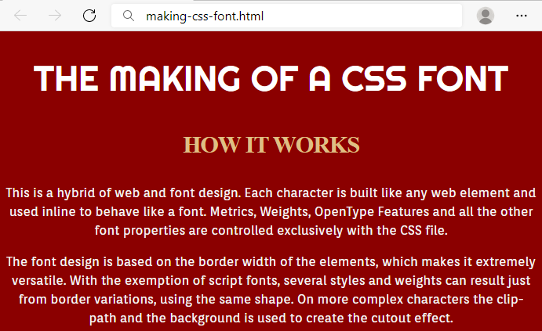

### Constraints

You will be given a skeleton with **filled** **HTML** and an **empty** **CSS** file. Write the missing **CSS** following the guidelines in the task.

* <body>:
  + Background color: **darkred**
* <h1>:
  + Font: **'Righteous'**
* Use CSS import: @import url('https://fonts.googleapis.com/css2?family=Righteous&display=swap');
  + Generic Font: **cursive**
  + Font size: **45px**
  + Font weight: **normal**
  + Height of the line: **60px**
  + Text color: **#fff**
  + All characters to be **UPPERCASE**
  + Align the **text** to the **center**
* <h2>:
  + Font size: **30px**
  + Height of the line: **50px**
  + Space between letters: **-1px**
  + Text color: #**DFBF84**
  + All characters to be **UPPERCASE**
  + Align the **text** to the **center**
* <p>:
  + Font: **'Orienta'**
* Use CSS import: @import url('https://fonts.googleapis.com/css2?family=Orienta&display=swap');
  + Generic Font: **sans-serif**
  + Font size: **16px**
  + Height of the line: **24px**
  + Text color: #**f6f6f6**
  + Align the **text** to the **center**

## Font Awesome Icons

Create a web page like the following:

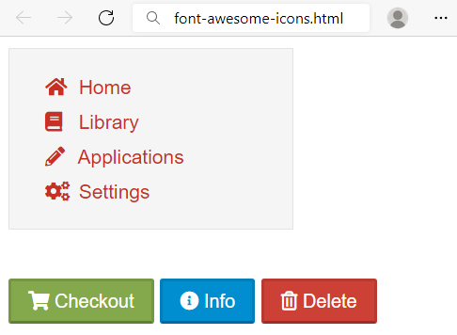

### Constraints

HTML with <body> that contains: <nav> and separately <p>.

* <nav> with
  + <ul> and in it
    - <li> and in it
      * <a> and in it
        + <i> + text
* <p> with three buttons
  + <button> with class="shopping"
  + <button> with class="info"
  + <button> with class="delete"

CSS:

* Import font awesome link
* <body>:
  + Fonts: **proxima-nova**, "**Helvetica** **Neue**", **Helvetica**, **Arial**
  + Generic Font: **sans-serif**
* <nav>:
  + Width: 200px
  + Solid border with size 1px and color #e3e3e3
  + Font size: **14px**
  + Height of the line: 20px
  + Background color: #f5f5f5
* <li>:
  + None list style
  + Height of the line: 25px
  + Left margin: -15px
* <a>:
  + None text decoration
  + Text color #c83025
* <i>:
  + Width: 1.14em
  + Right padding: 0.28em

For all the **buttons**:

* **Top** & bottom padding 4px
* **Left** & **right** padding 12px
* Height of the line: 20px
* Text color: #ffffff
* Border color: rgba(0, 0, 0, 0.1) rgba(0, 0, 0, 0.1) rgba(0, 0, 0, 0.25)
* Cursor: pointer

For the **button.shopping**:

* Background color: **#83a94c**

For the **button.info**:

* Background color: **#008ed0**

For the **button.delete**:

* Background color: **#cc4036**

## Icon Font Buttons

Create a web page like the following:

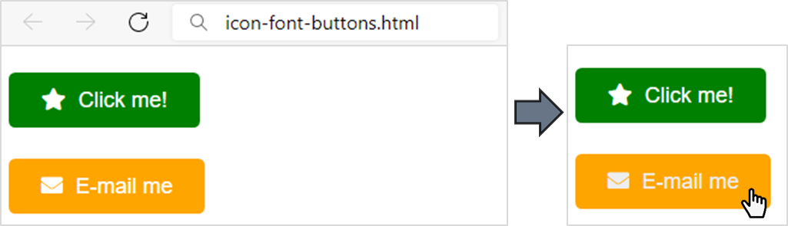

### Constraints

You will be given a skeleton with **HTML** and an **empty** **CSS** file. Write the missing **CSS and HTML** following the guidelines in the task.

Add icons with the following classes in the **HTML** <a> tag: fas fa-star, fas fa-envelope.

* <body>:
  + Font: **Arial**
  + Generic Font: **serif**
  + Height of the line: **3**
  + Font size: **18px**
* <a>:
  + **None** text decoration
  + Text color: **#fff**
  + Set the border radius to **5.40px**
  + **Top** & bottom paddings 12.6**px**
  + **Left** & **right** paddings 27px
* When the mouse course is over (a:hover):
  + Change the **text color** to **#eee**
* <i>:
  + Right padding: **5.40px**
* The **anchor** with class="green"> (you can select them like that: .green)
  + Background color: green
* The **anchor** with class="orange"> (you can select them like that: .orange)
  + Background color: orange
* Use **FontAwesome** for this task. Import it in your CSS, with the @import rule

## Icon Font List

Create a webpage like the following:

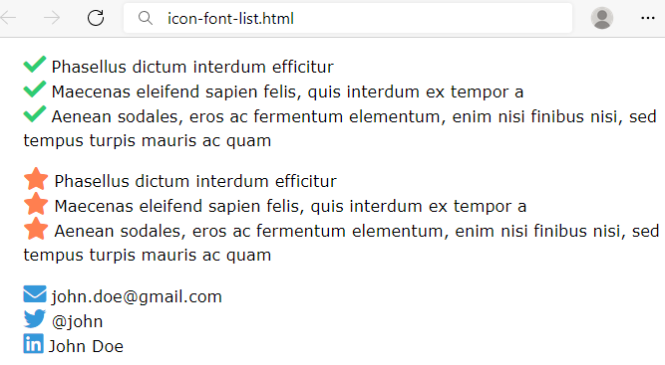

### Constraints

You will be given a skeleton with **HTML** and an **empty** **CSS** file. Write the missing **CSS and HTML** following the guidelines in the task.

Add icons with the following classes in the **HTML** <li> tag: fas fa-check, fas fa-star, fas fa-envelope, fab fa-twitter, fab fa-linkedin.

* <body>:
  + Font: **Verdana, Geneva, Tahoma**
  + Generic Font: **sans-serif**
  + Height of the line: **1.5**
  + Font size: **18px**
* <ul>:
  + Set the list style type to none
* The icons in the <ul class="check"> (you can select them like that: ul.check i)
  + Color: #2fcc71
  + Font size: **25px**
* The icons in the <ul class="star"> (you can select them like that: ul.star i)
  + Color: coral
  + Font size: **25px**
* The icons in the <ul class="contact"> (you can select them like that: ul.contact i)
  + Color: #3498da
  + Font size: **25px**
* Use **FontAwesome** for this task. Import it in your CSS, with the @import rule

## Create Typography CSS

Create a web page like the following:

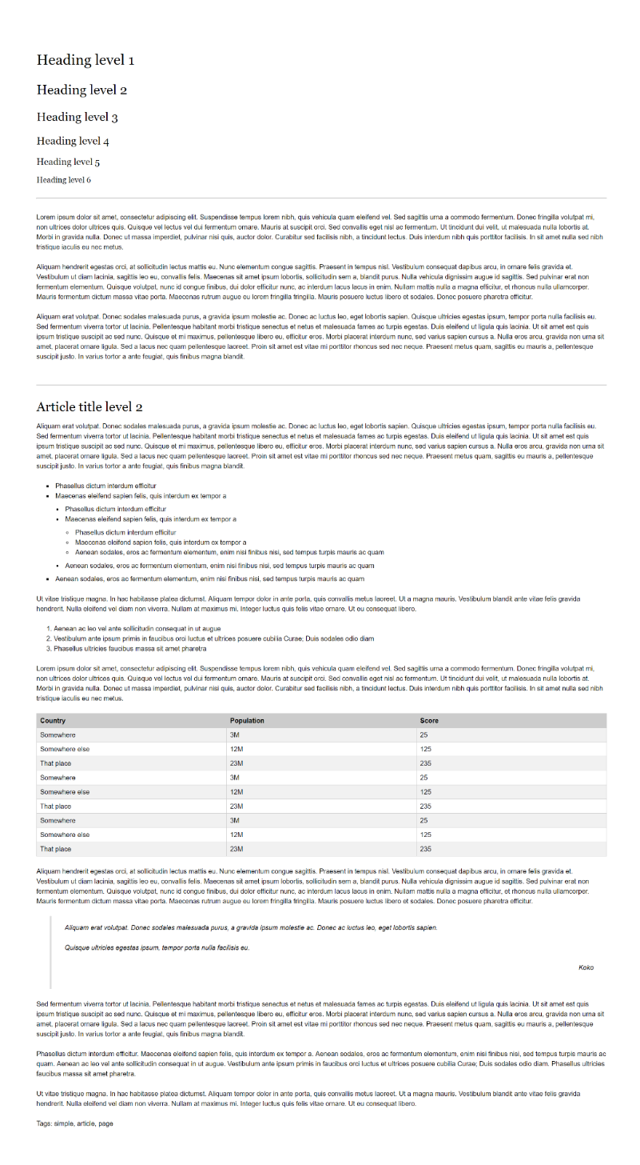

### Constraints

* Create an **"**index.html**"** and **"**style.css**"** files
* Change the document **title** to "**Typography**"
* Use Helvetica, sans-serif font-family for the document
  + Make the font-size 16px
  + Change the line-height to 1.5
* Use Georgia, serif font-family for the headings
* Use headings from h1 to h6
* Create a HTML table and style it
* Use blockquote tag
  + Style its left border with rgb(221,221,221) color
  + Style its font to italic
* Use hr tag for the horizontal lines